**1** Match each statement on ecology with the correct term listed below.

**a)** A group of several populations of different species living in the same habitat.

**b)** All the organisms of the same species living in the same area.

**c)** Competition between organisms of different species living in the same community.

**d)** All the living factors in the environment

**e)** Competition between members of the same species living in the same habitat.

abiotic  intraspecific  community  populaton  interspecific  biotic (5)

**f)** There is one term that has not been used. Write your own definition for this term and give two examples. (3)

**2** The diagram shows the cycling of carbon in nature.

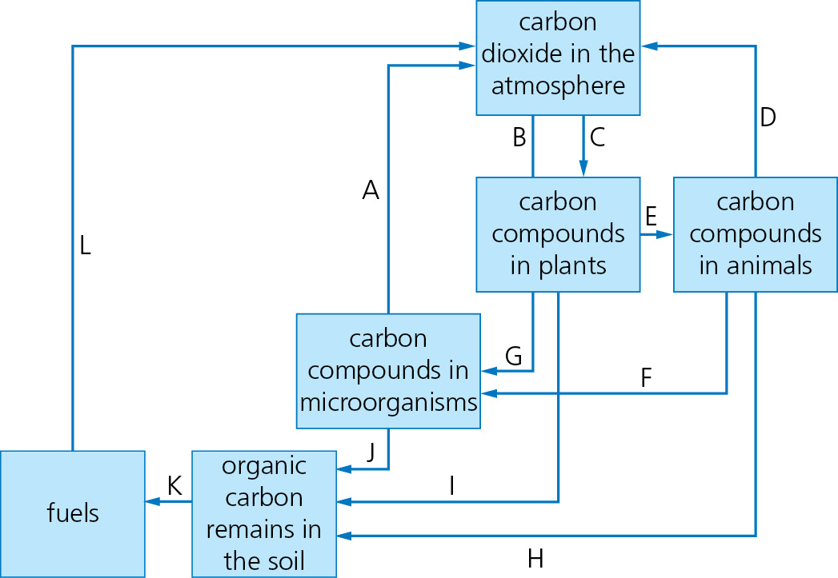

**a)** Select the label letter on the diagram which is correctly described by the definitions in the table.

|  |  |
| --- | --- |
| **Definition** | **Letter** |
| Animal feeding |  |
| Combustion |  |
| Photosynthesis |  |
| Death |  |
| Plant respiration |  |

(5)

**b)** Give examples of the following carbon compounds:

**i)** A carbon compound found in both animals and plants.

**ii)** A fossil fuel.

**iii)** A carbon compound that is found only plants but not animals. (3)

**3** A group of students were examining the abundance of bluebells along a transect line from the middle of a wood to its outer edge. A 0.5 m2 quadrat was placed every 5 m along the transect. The students estimated the percentage cover of bluebells in each quadrat.

**a)** One of the quadrats is shown below. Estimate the % cover of the three plants in this quadrat.

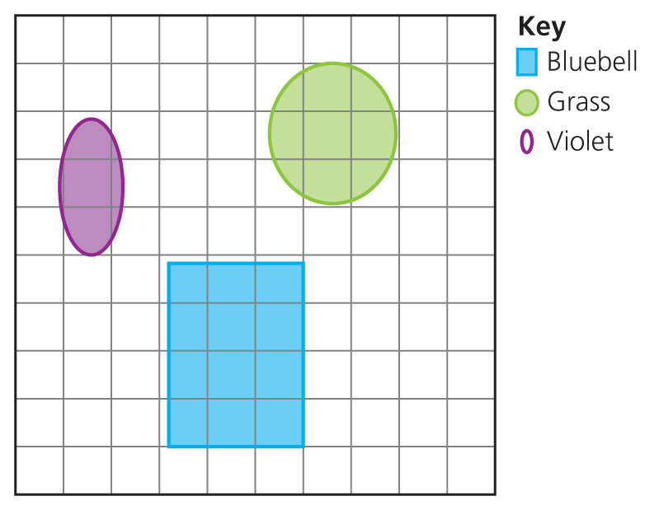

Bluebell = ; Grass = ; Violet = (3)

The light intensity at each location was also measured. All the results were recorded in a table.

|  |  |  |
| --- | --- | --- |
| Distance along transect (m) | Abundance of bluebells (% cover) | Light intensity (arbitrary units) |
| 0 | 90 | 1 |
| 5 | 75 | 2 |
| 10 | 57 | 4 |
| 15 | 36 | 6 |
| 20 | 15 | 8 |
| 25 | 4 | 9 |
| 30 | 2 | 9 |

**b)** What is the relationship between the number of bluebells and the light intensity? (1)

**c)** Why do you think this is? (1)

**d)** At what distance do you think the students were just out of the wood? (1)

**e)** Give a reason for your answer. (1)

**f)** What other abiotic factor could have been sampled at each point along the transect which might account for the changing abundance of the bluebells? (1)

**4** The water cycle shows how water is constantly moving around the planet.

**a)** Identify processes 1–4 on the diagram of the water cycle. (4)

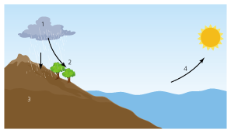

**b)** Process 3 creates ground water. This can be stored in underwater areas. What are these storage areas called? (1)

**c)** Plants can also return water to the atmosphere. What is the name of this process that plants carry out? (1)

**d)** Some areas of the planet have very little water and the organisms living there have to be highly adapted. Name a plant that can survive in such an area and explain any adaptations that help it. (2)

**e)** Some organisms can be used to tell how polluted water is. What term is used to describe these organisms? (1)

**f)** Heavily polluted water has very little dissolved oxygen. The invertebrates in the diagram are found in heavily polluted water.

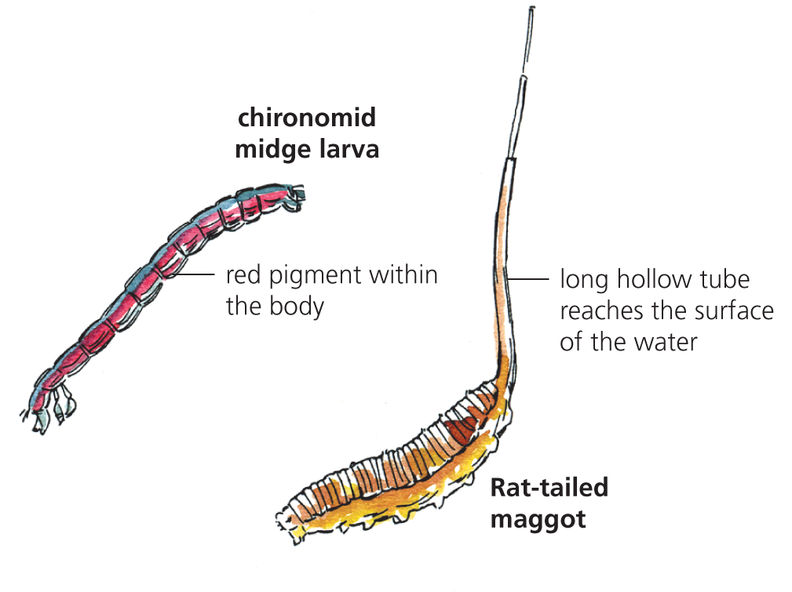

For each organism, explain how it is adapted and how it is able to survive. (4)

**5 a)** Put the organisms in the food chain into the correct order.

Carnivore → Producer → Herbivore (2)

**b)** Which of the organisms in the food chain are consumers? (2)

**c)** To which group would algae belong? (1)

**d)** What is an omnivore? (1)

**e)** What role do decomposers play in a food chain? (2)

**f)** The diagram shows an animal feeding.

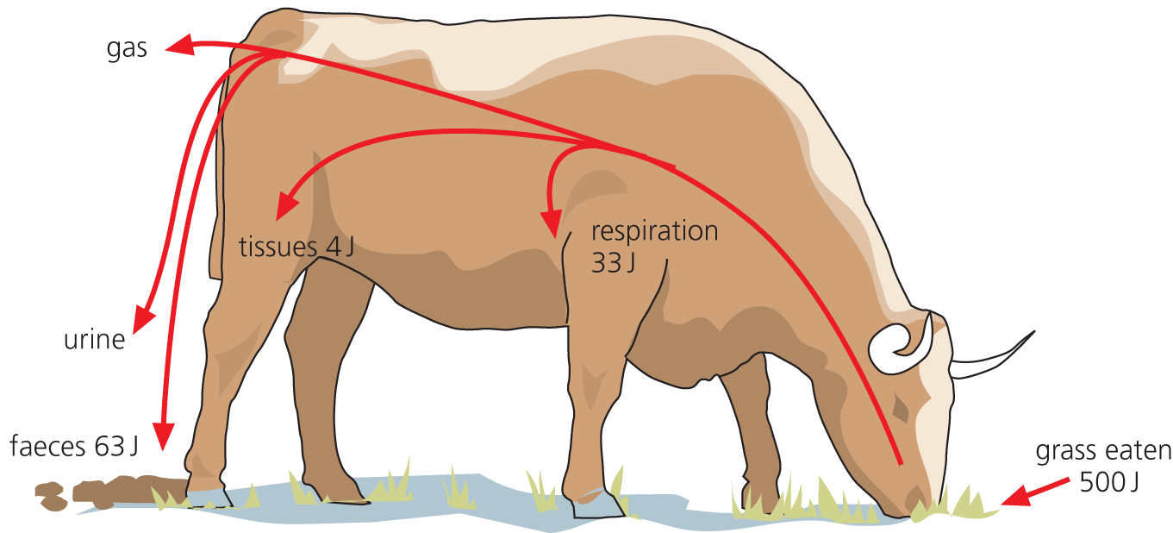

**i)** To what feeding group does the animal in the diagram belong? (1)

**ii)** What percentage of the food eaten by the animal is lost as faeces?

(Show your working.) (2)

**iii)** What percentage of the food eaten is converted to biomass? (Show your working.) (2)

TOTAL = 50

**1 a)** community

**b)** population

**c)** interspecific

**d)** biotic

**e)** intraspecific (5)

**f)** Abiotic factors are the non-living components of an ecosystem; temperature, pH, carbon dioxide levels, soil type, water levels. (1 for definition; 2 for named examples = 3)

**2 a)**

|  |  |
| --- | --- |
| Definition | Letter |
| Animal feeding | **E** |
| Combustion | **L** |
| Photosynthesis | **C** |
| Death of animals | **F** |
| Plant respiration | **B** |

(5)

**b) i)** glucose

**ii)** coal, oil or natural gas

**iii)** starch or cellulose (3)

**3** **a)** bluebell = 10% (allow 8–12); grass = 7% (allow 6–8%); violet = 3% (3)

**b)** As the light intensity increases, the number of bluebells decrease (ora) (1)

**c)** Bluebells are shade-loving plants/adapted to live in low light intensities. (1)

**d)** 25 m along the line (1)

**e)** The light intensity was at its maximum and did not change at the next sampling point. (1)

**f)** soil temperature, air temperature, soil pH, water (1)

**4** **a)** 1 = condensation; 2 = precipitation/rainfall/snow; 3 = infiltration; 4 = evaporation. (4)

**b)** aquifers (1)

**c)** transpiration (1)

**d)** Cactus: leaves reduced to spines to reduce water loss; thick waxy cuticle; deep roots.

Or

Fir tree; arctic tundra leaves reduced to needles to reduce water loss.

(named organism and the adaptation explained = 2)

**e)** bioindicators (1)

**f)** Chironomid midge larva has (red) haemoglobin in body. It uses the haemoglobin to absorb as much oxygen as possible from the water and hold on to it.

Rat-tailed maggot has a long hollow breathing tube. The tube reaches above the water level so it can take in oxygen from the air (rather than rely on oxygen in water). (2 marks for 2 points for each animal = 4)

**5** **a)** Producer → Herbivore → Carnivore (2)

**b)** herbivore and carnivore (2)

**c)** producers (1)

**d)** An animal that eats both plants and animals. (1)

**e)** Decomposers break down dead plants and animals and excretory products; they return useful compounds to the soil; the compounds are available for the producers to absorb; decomposers recycle organic matter. (2)

**f)** **i)** herbivore (1)

**ii)** 63/500 × 100 = 12.6% (2)

**iii)** 4/500 × 100 = 0.8% (2)

TOTAL = 50